Round Robin=
#include <stdio.h>

int main()
{
int n, tq;
int at[20], bt[20], rt[20];
int ct[20], tat[20], wt[20], res[20];
int time = 0, remain, flag = 0;

printf("Enter number of processes: ");
scanf("%d", &n);

for(int i = 0; i < n; i++)
{
printf("Enter Arrival Time and Burst Time for P%d: ", i+1);
scanf("%d %d", &at[i], &bt[i]);

rt[i] = bt[i];
res[i] = -1;
}

printf("Enter Time Quantum: ");
scanf("%d", &tq);

remain = n;

printf("\nGantt Chart:\n");
printf("%d", time);

while(remain != 0)
{
flag = 0;

for(int i = 0; i < n; i++)
{
if(rt[i] > 0 && at[i] <= time)
{
if(res[i] == -1)
res[i] = time - at[i];

if(rt[i] > tq)
{
time += tq;
rt[i] -= tq;
}
else
{
time += rt[i];
rt[i] = 0;
ct[i] = time;
remain--;
}

printf(" | P%d | %d", i+1, time);
flag = 1;
}
}

if(flag == 0)
time++;
}

printf("\n\nProcess\tAT\tBT\tCT\tTAT\tWT\tRT\n");

for(int i = 0; i < n; i++)
{
tat[i] = ct[i] - at[i];
wt[i] = tat[i] - bt[i];

printf("P%d\t%d\t%d\t%d\t%d\t%d\t%d\n",
i+1, at[i], bt[i], ct[i], tat[i], wt[i], res[i]);
}

return 0;
}
Output=
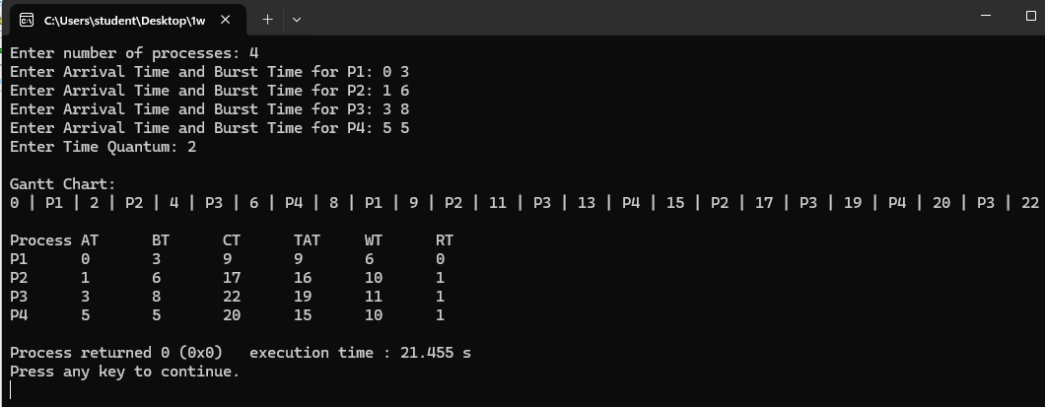
Multilevel Algorithm=
#include <stdio.h>

int main()
{
int n, i, j, time = 0;
int at[10], bt[10], ct[10], tat[10], wt[10];
int type[10];

printf("Enter number of processes: ");
scanf("%d", &n);

for(i = 0; i < n; i++)
{
printf("Enter AT and BT for P%d: ", i+1);
scanf("%d %d", &at[i], &bt[i]);

printf("Enter type (1-System , 0-User): ");
scanf("%d", &type[i]);
}

printf("\nExecution Order:\n");

for(i = 0; i < n; i++)
{
if(type[i] == 1)
{
if(time < at[i])
time = at[i];

time += bt[i];
ct[i] = time;

printf("P%d ", i+1);
}
}

for(i = 0; i < n; i++)
{
if(type[i] == 0)
{
if(time < at[i])
time = at[i];

time += bt[i];
ct[i] = time;

printf("P%d ", i+1);
}
}

printf("\n\nProcess\tAT\tBT\tType\tCT\tTAT\tWT\n");

for(i = 0; i < n; i++)
{
tat[i] = ct[i] - at[i];
wt[i] = tat[i] - bt[i];

if(type[i] == 1)
printf("P%d\t%d\t%d\tSystem\t%d\t%d\t%d\n", i+1, at[i], bt[i], ct[i], tat[i], wt[i]);
else
printf("P%d\t%d\t%d\tUser\t%d\t%d\t%d\n", i+1, at[i], bt[i], ct[i], tat[i], wt[i]);
}

return 0;
}
Output=
